**DATABASE DESIGN**

**CAR RENTAL SYSTEM**

**TEAM MEMBERS:**

T.Goutham (2B) 187266

M.Jithender Reddy (2B) 187232

P.Vamshi Krishna (2B) 187243

**Problem Statement:-**

The Process on searching the client details is slow if the company is using manual system and there are thousands of clients. Besides that, staffs have to record the booking manually and it is difficult to produce a monthly report or an annual report. Manual system does not allow client to booking online and hard to keep track on the record of rental cars.

**INTRODUCTION:-**

We have chosen to produce a Car Rental system. In our system, Customer can rent a car based on make and a model. Our system provides customer to have different pick-up and drop-off locations and will impose late fee if the rental car is returned beyond the return date and time.

**ENTITIES:-**

* 1. **Customer:**

Customer will be the one who is using car rental system for reserving a car. Customer entity will store details like customer driving license number, email, address, name, and phone number.

* 1. **Car:**

Car entity will have list of cars available in the system. Each car will be associated with a car category and car will have attributes like model, mileage and registration number. Car will also have separate flag to check the availability of the car.

* 1. **Car Category:**

Every car has a car category. Price is calculated based on the car category. Car category will have attributes like no of person, no of luggage’s, name, and cost per day and late fee.

**d) Location**

Location entity here denotes the pickup and drop off location of the car. Customer can pick up the car from the particular location and can have same or different drop off location. Location will have attributes like Location id, name and address.

* 1. **Booking**

Each car reservation will be monitored in the entity called booking. Booking will have attributes like booking id, from date and time of booking and due return date and time and actual return date and time of the booking, and booking status.

* 1. **Billing**

When a customer returns a car, a bill will be generated on the particular booking. Billing have attributes like Bill ID, bill date, bill status, total late fee, and total amount.

**RELATIONS:-**

* 1. **Car to Car Category:**

Every car is associated with a car category. Once customer selects a car, the cost per day is obtained from the car category that the selected car belongs to. The relation name is ‘Belongs to’.

**b) Car to Location:**

Customer will be picking up or dropping the car in a particular location. Customer can pick up or drop-off the car at the particular location. So, cars will be present at a location. The relation name is ‘Current location’

**c) Booking to Billing:**

Once customer returns a car bill will be generated for each booking. There can be case like booking is cancelled in that case no bill will be associated with the booking. The relation name is ‘Gives’.

**d)** **Booking to Location:**

Customer can pick a car for rent from a particular location. The relation name is ‘Pick up location’.

**e)** **Booking to Location:**

Customer can drop off rental car in a particular location. The relation name is ‘Drop off location’.

* 1. **Customer to Car to Booking:**

Customer will select car for rent. So the customer will be related to the both car and the booking. The relation between these 3 entities is a ternary relation and the relation name is ‘Rents’.

**ENTITY RELATIONSHIP**

**MODEL(ER)**

**CAR RENTAL SYSTEM**

billing

gives

Drop location

Pickup location

bookings

location

Car category

Current location

car

rents

customers

Belongs to

**SCHEMA DIAGRAM OF**

**CAR RENTAL SYESTEM**

|  |
| --- |
| car |
| Registration_no |
| Availability_flag |
| model |
| mileage |

|  |
| --- |
| Customer |
| Driving _licence_id |
| name |
| Ph_no |
| address |
| Email |

|  |
| --- |
| Rents |
| Driving_licence_id |
| Registration_no |
| Booking_id |

|  |
| --- |
| Booking |
| Booking_id |
| From_date |
| To_date |
| Amount |
| Booking_status |

|  |
| --- |
| Location |
| Location_id |
| Name |
| Street |
| City |
| Pincode |
| State |

|  |
| --- |
| Belongs_to |
| Registration_no |
| Name |

|  |
| --- |
| Billing |
| Bill_id |
| Bill_date |
| Bill_status |
| Total_late_fee |
| Total_amount |

|  |
| --- |
| Car_category |
| Name |
| No_of_persons |
| No_of_luggage |
| Cost_per_day |
| Late_fee |

|  |
| --- |
| Pick_up_location |
| Location_id |
| Booking_id |

|  |
| --- |
| Gives |
| Bill_id |
| Booking_id |

|  |
| --- |
| Current_location |
| Registration_No |
| Location_id |

|  |
| --- |
| Drop_of_location |
| Location_id |
| Booking_id |

|  |  |
| --- | --- |
| Entities | Attributes |
| customer | Pk-( driving_licence_id),email,cus_name,address,ph_no |
| car | Pk-(registration_no),fk-(driving_license_id,cname,location_id,  Booking_id),model_name,mileage,availability_flag |
| bookings | Pk-(booking_id), booking_status,amount,to_date1,from_date  Fk-(pic_Location_id,drop_location_id,driving_license_id), |
| billing | Pk-(bill_id),fk-(booking_id),bill_status,total_late_fee,  total_amount,bill_date |
| car category | Pk-(cname),no_of_persons,late_fee,cost_per_day,  no_of_luggage |
| locations | Pk-(location_id),loc_name,street,city,state_name,pincode |

From above ER diagram we get:-

**From above ER diagram functional dependencies are:-**

Customers table:-

driving_license_id -> {cus_name,address,email}

car_category:-

cname -> {no_of_persons,late_fee,cost_per_day,no_of_luggage}

locations:-

Loc_name -> {street,city,state_name,pincode}

Pincode -> { state_name , city}

Bookings:-

Booking_id >{pic_location_id,drop_location_id,driving_license_id,amount,booking_status

,to_date1,from_date}

billing:-

billing_id -> {booking_id,bill_status,total_late_fee,total_amount,bill_date}

car:-

Registration_no -> {driving_license_id,cname,location_id,booking_id,model_name,mileage,availability_flag}

**Normalization Of Tables:-**

1st normal form:-

In customers table ph_no is multivalued attribute hence we divided into a new table customerph having attributes driving_license_id,ph_no.

2nd normal form:-

As all non key attributes fully dependent on key attributes. Hence its already in 2nd normal form.

3rd normal form:-

In locations table some non key attributes are in transitive dependent to key attributes hence we decomposed locations table into 2 tables locations having attributes loc_id, loc_name, street, pincode and pinlocations having attributes pincode, state, city.

BCNF :-

As all key attributes are in left side of functional dependencies hence it is in BCNF.

|  |  |
| --- | --- |
| Entities | Attributes |
| customer | Pk-( driving_licence_id),email,cus_name,address |
| car | Pk-(registration_no),fk-(driving_license_id,cname,location_id,  Booking_id),model_name,mileage,availability_flag |
| bookings | Pk-(booking_id), booking_status,amount,to_date1,from_date  Fk-(pic_Location_id,drop_location_id,driving_license_id), |
| billing | Pk-(bill_id),fk-(booking_id),bill_status,total_late_fee,  total_amount,bill_date |
| car_category | Pk-(cname),no_of_persons,late_fee,cost_per_day,  no_of_luggage |
| locations | Pk-(location_id),loc_name,street,fk-(pincode) |
| customerph | fk-(driving_license_id),ph_no |
| pinlocation | Pk-(Pincode),state_name,city |

**After normalization:-**

**Creation and insertion of tables:-**

create table customer(driving_license_id varchar2(20),primary key(driving_license_id),email varchar2(40),cus_name varchar2(20),address varchar2(200));

create table locations(location_id varchar2(20),primary key(location_id),loc_name varchar2(20),street varchar2(20),pincode int );

create table pinlocation(pincode int,primary key(pincode) ,state_name varchar2(20),city varchar2(20));

create table car_category(cname varchar2(20),primary key(cname),no_of_persons int,late_fee int,cost_per_day int,no_of_luggage int);

create table bookings(booking_id varchar2(20),primary key(booking_id),pic_location_id varchar2(20),drop_location_id varchar2(20),foreign key (pic_location_id) REFERENCES locations(location_id),foreign key (drop_location_id) REFERENCES locations( location_id),driving_license_id varchar2(20),foreign key (driving_license_id) REFERENCES customer(driving_license_id),amount int,

booking_status varchar2(20),to_date1 varchar2(20),from_date varchar2(20));

create table billing(bill_id varchar2(20),primary key(bill_id),booking_id varchar2(20),foreign key(booking_id) REFERENCES bookings(booking_id),bill_status varchar2(20),

total_late_fee int,total_amount int,bill_date varchar2(20));

create table car(registration_no varchar2(20),primary key(registration_no),driving_license_id varchar2(20),foreign key(driving_license_id)references customer(driving_license_id)

,cname varchar2(20),foreign key(cname) references car_category(cname),location_id varchar2(20),foreign key (location_id) references locations(location_id),booking_id varchar2(20),

foreign key (booking_id) references bookings(booking_id),model_name varchar2(20),mileage int,availability_flag int);

create table customerph(driving_license_id varchar2(20),foreign key(driving_license_id)REFERENCES customer(driving_license_id),ph_no int);

screen shot of creation of tables:-

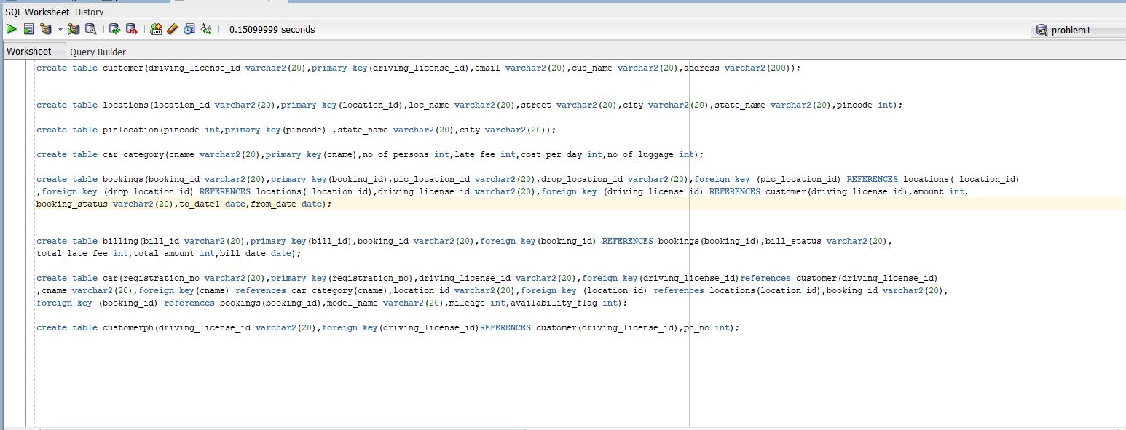

Screenshot of creation of tables:-

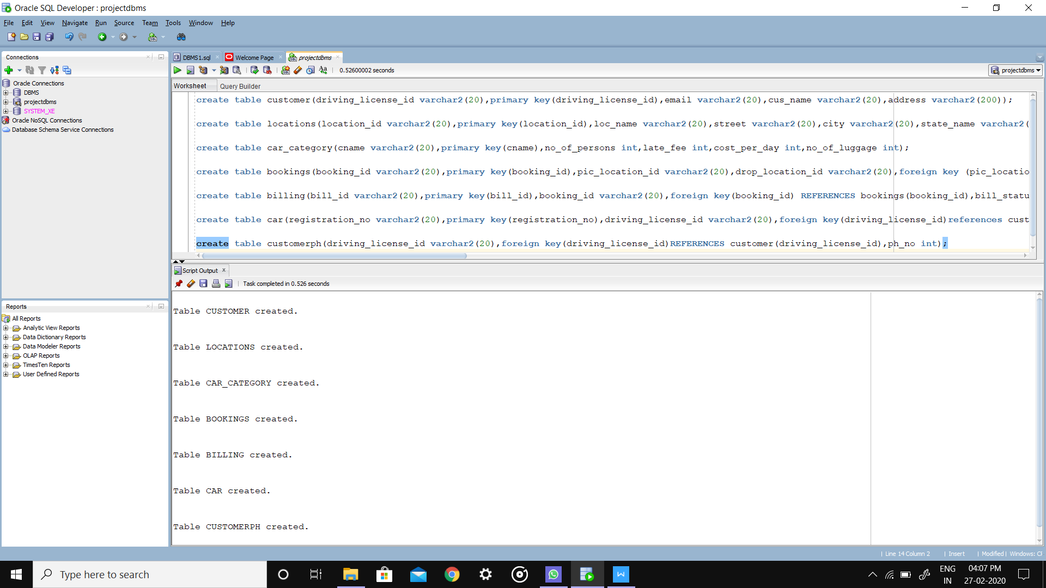

Insertion of customers table:-

insert into customer values('d121','jithender','ramannapet,bhongir,telangana','jithenderamamidi122@gmail.com');

insert into customer values('d122','goutham','madhapur,hyderbad,telangana','tatipalligoutham@gmail.com');

insert into customer values('d123','vamshi',' nagarkurnool,mahabubnagar,telangana','3vamshi3@gmail.com');

insert into customer values('d124','sairam','aler,janagon,telangana','sairam12@gmail.com');

insert into customer values('d125','avinash','valiginda,rajamundry,andrapradesh','manyamavinash34@gmail.com');

insert into customer values('d126','roshik',' chityala,mahabubnagar,telangana','roshik223@gmail.com');

insert into customer values('d127','srivatsa','uppal,hyderbad,telangana','srivatsa271@gmail.com');

insert into customer values('d128','vinod','dhoddimekhala,kurnool,andrapradesh','kuruvavinod2221@gmail.com');

insert into customer values('d129','uday','narsapur,west godhavari,andrapradesh','udaykiran521@gmail.com');

insert into customer values('d130','likith','ghatkesar,rangareddy,telangana','likithchinthala654@gmail.com');

insertion of locations values :-

insert into locations values('l101','kphb bus stop','kukatpally',500001);

insert into locations values('l102','lp bus stop','lingampally',500050);

insert into locations values('l103','wgl bus stop','kohaku road',504001);

insert into locations values('l104','wgl railway station','senku road',504001);

insert into locations values('l105','hnk bus stop','raina road',504009);

insert into locations values('l106','kzp railway station','warner road',504011);

insert into locations values('l107','upl bus stop','L road',500025);

insert into locations values('l108','mbnr bus stop','zoro road',509001);

insert into locations values('l109','mbnr railway station','luffy road',509001);

insert into locations values('l110','ngkl bus stop','sasuke road',509209);

insert into locations values('l111','ngkl railway station','naruto road',509209);

insertion of pinlocation values:-

insert into pinlocation values(500001,'telangana','lingampally');

insert into pinlocation values(500050,'telangana','kukatpally');

insert into pinlocation values(504001,'telangana','warangal');p

insert into pinlocation values(504009,'telangana','hanamkonda');

insert into pinlocation values(504011,'telangana','kazipet');

insert into pinlocation values(500025,'telangana','uppal');

insert into pinlocation values(509001,'telangana','mahabubnagar');

insert into pinlocation values(509209,'telangana','nagarkurnool');

insertion of car_category values:-

insert into car_category values('ECONOMY',5,9,30,2);

insert into car_category values('COMPACT',5,3,32,3);

insert into car_category values('MID SIZE',5,13,35,3);

insert into car_category values('STANDARD',5,14,38,3);

insert into car_category values('FULL SIZE',5,12,40,4);

insert into car_category values('LUXURY CAR',5,25,75,5);

insert into car_category values('MID SIZE SUV',5,18,36,2);

insert into car_category values('STANDARD SUV',5,12,40,3);

insert into car_category values('FULL SIZE SUV',8,18,60,2);

insert into car_category values('MINI VAN',7,2,70,5);

insertion of booking values:-

insert into bookings values('b101','l101','l105','d125',2000,'yes','2019-12-06','2019-12-17');

insert into bookings values('b102','l105','l106','d121',4000,'no','2019-12-08','2019-12-27');

insert into bookings values('b103','l106','l109','d123',200,'pending','2019-12-16','2019-12-17');

insert into bookings values('b104','l107','l101','d127',1000,'cancelled','2019-12-26','2019-12-31');

insert into bookings values('b105','l102','l103','d122',1500,'cancelled','2019-12-12','2019-12-20');

insert into bookings values('b106','l105','l110','d124',1500,'no','2019-12-08','2019-12-18');

insert into bookings values('b107','l109','l103','d126',200,'yes','2019-12-03','2019-12-23');

insert into bookings values('b108','l102','l107','d128',800,'yes','2019-12-13','2019-12-23');

insert into bookings values('b109','l108','l106','d123',900,'yes','2019-12-15','2019-12-30');

insert into bookings values('b110','l110','l108','d122',500,'yes','2019-12-06','2019-12-30');

insertion of billing values:-

insert into billing values('i110','b101','completed',200,500,2020-01-02);

insert into billing values('i101','b102','completed',100,1000,2020-01-21);

insert into billing values('i102','b104','pending',120,1020,2020-01-22);

insert into billing values('i103','b106','completed',190,840,2020-02-01);

insert into billing values('i104','b103','pending',800,2800,2020-01-02);

insert into billing values('i105','b107','pending',390,1800,2020-01-15);

insert into billing values('i106','b105','completed',713,3913,2020-02-03);

insert into billing values('i107','b109','completed',1000,4500,2020-01-31);

insert into billing values('i108','b110','completed',950,3600,2020-02-07);

insert into billing values('i109','b108','pending',670,1470,2020-05-03);

insertion of car values:-

insert into car VALUES('r201','d121','ECONOMY','l101','b101','CIVIC',20,1);

insert into car VALUES('r202','d122','COMPACT','l102','b102','FIESTA',19,1);

insert into car VALUES('r203','d123','MID SIZE','l103','b103','POLO',12,0);

insert into car VALUES('r204','d124','STANDARD','l104','b104','CRUZE',10,1);

insert into car VALUES('r205','d125','STANDARD SUV','l105','b105','SCORPIO',8,1);

insert into car VALUES('r206','d126','MINI VAN','l106','b106','MAGIC',15,1);

insert into car VALUES('r207','d127','LUXURY CAR','l107','b107','Q3',6,1);

insert into car VALUES('r208','d128','FULL SIZE SUV','l108','b108','FORTUNER',9,1);

insert into car VALUES('r209','d129','MID SIZE SUV','l109','b109','INNOVA',4,0);

insert into car VALUES('r210','d130','FULL SIZE','l110','b110','BOLERO',10,0);

insert into car VALUES('r215','d130','COMPACT','l101','b103','SWIFT',19,1);

insert into car VALUES('r213','d126','STANDARD','l105','b108','BALENO',25,1);

insert into car VALUES('r211','d122','LUXURY CAR','l108','b104','FERRARI',5,1);

insert into car VALUES('r214','d129','MINI VAN','l103','b106','BAJAJ',19,0);

insert into car VALUES('r212','d125','ECONOMY','l105','b104','DUSTER',12,0);

insertion of customerph values:-

insert into customerph values('d121',9154173452);

insert into customerph values('d121',8946325237);

insert into customerph values('d122',7185784929);

insert into customerph values('d122',8300428020);

insert into customerph values('d123',2987895899);

insert into customerph values('d123',9652264789);

insert into customerph values('d124',9683897863);

insert into customerph values('d125',8967239082);

insert into customerph values('d126',7890290470);

insert into customerph values('d127',8231748639);

insert into customerph values('d128',7294204849);

insert into customerph values('d129',7844098404);

insert into customerph values('d130',9388299492);